# Document Examples

## 1- Creating Simple RESTful API using [Express.js](https://expressjs.com/)

***Create a basic server*** *using Express.js. It sets up middleware to parse incoming JSON data. The server listens on a port 3000 and the server starts listening for requests, logging the port number when it begins running.*

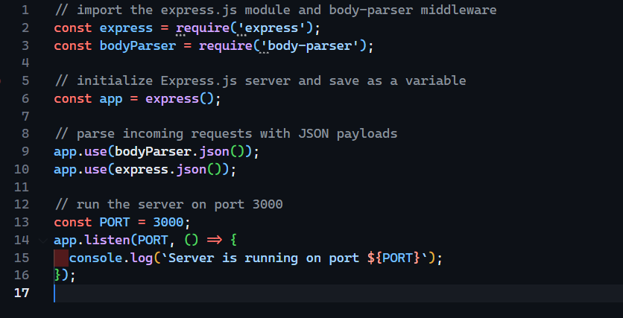

*An empty array (todos) is initialized for storing data in memory and setting up verify token middleware*

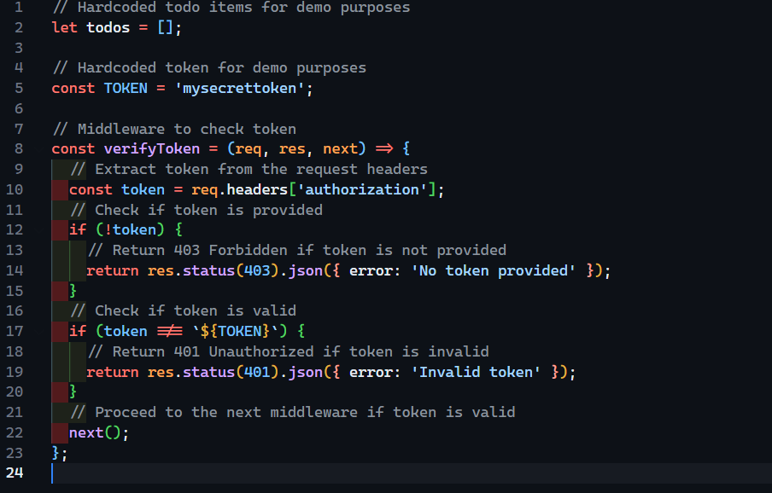

***GET*** *endpoint to fetch all tasks*

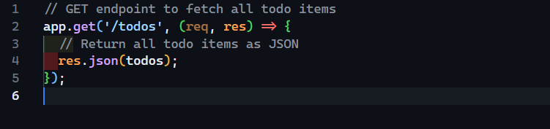

***POST*** *endpoint to create a new to-do item, provide `title` and optionally `completed` in the request body as JSON*

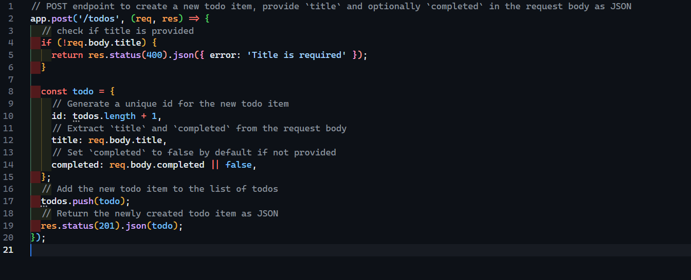

***PUT*** *endpoint to update an existing to-do item with the specified `id`, provide updated `title` and/or `completed` in the request body as JSON*

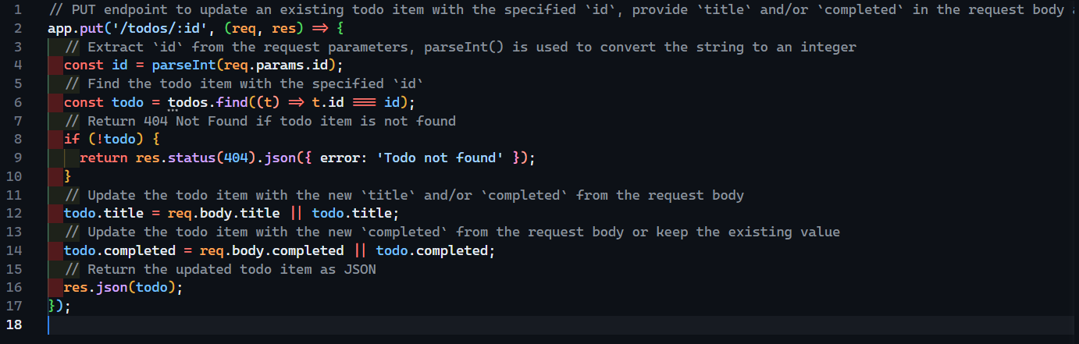

***DELETE*** *endpoint to remove an existing todo item with the specified `id`*

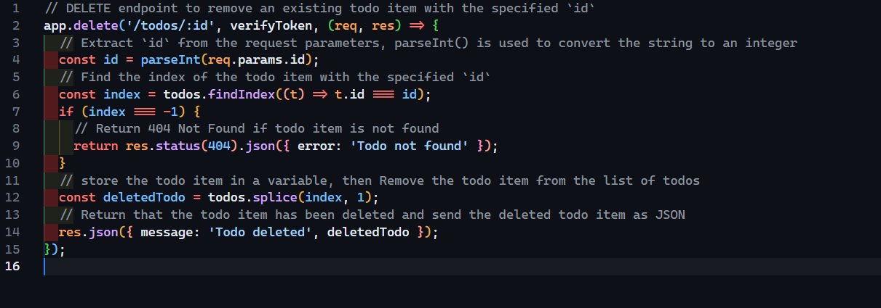

***Middleware*** *to handle 404 errors by returning a JSON response with an error message*



 